ETL_Mini_Project_Team4.ipynb

Option-1-

Option-2

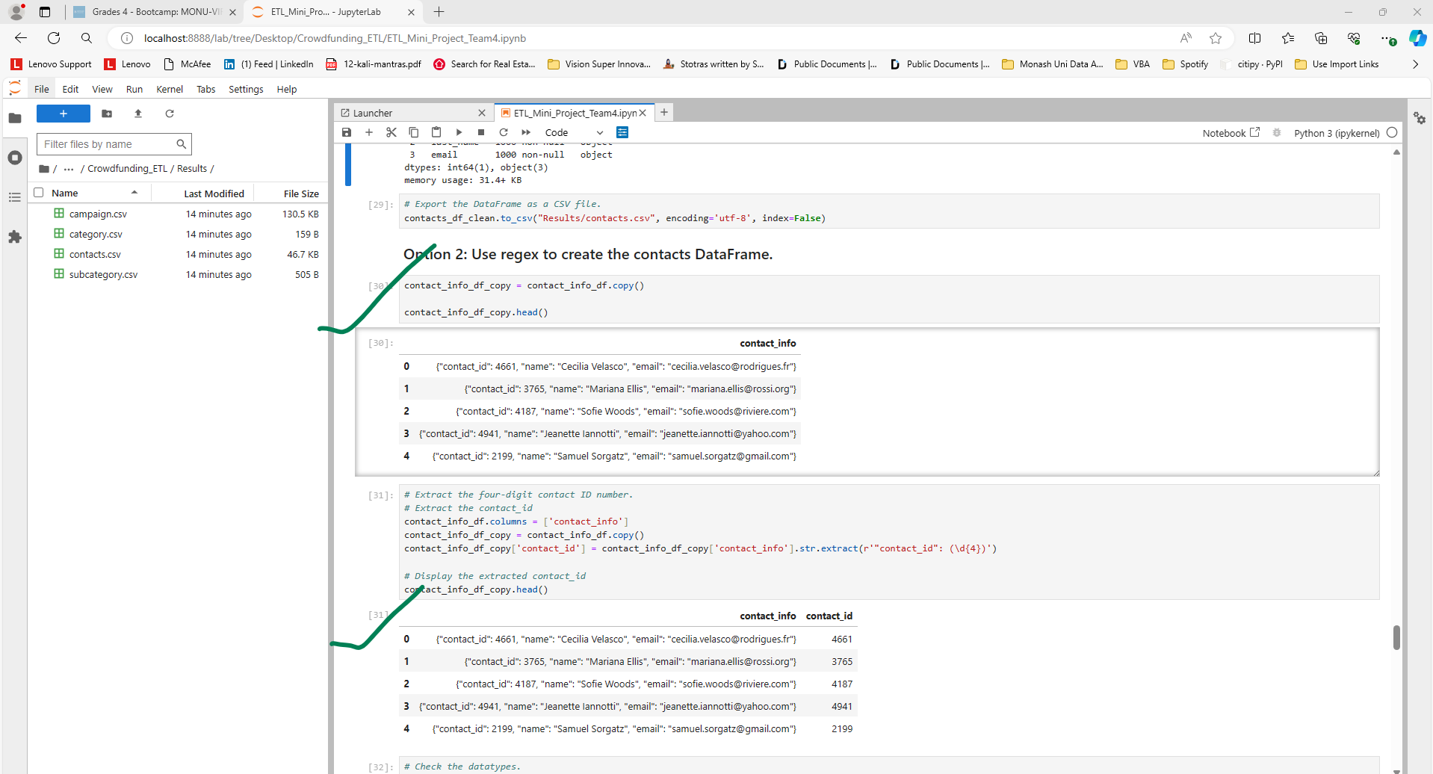

Database – crowfunding_ETL

4 Tables created successfully

Now import the data from the category csv files into category table

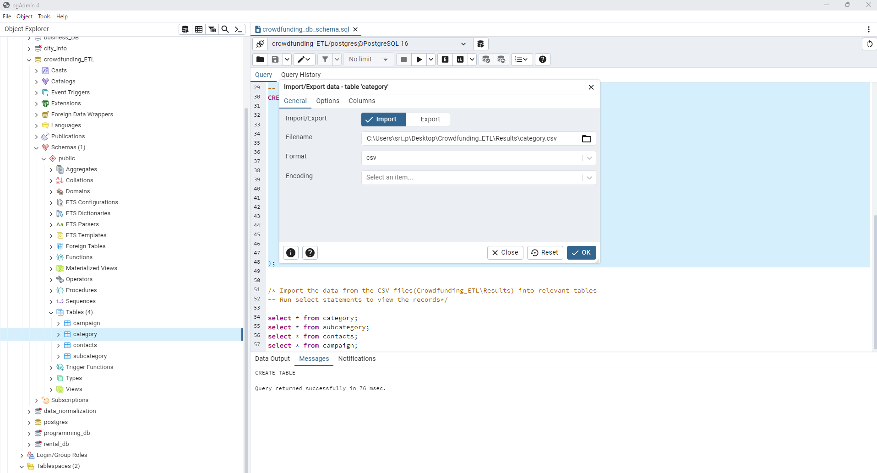

Import the data from the subcategory csv files into subcategory table

Import the data from the contacts csv files into contacts table

Import the data from the campaign csv files into campaign table

